“4 on the Floor” Bass Pattern
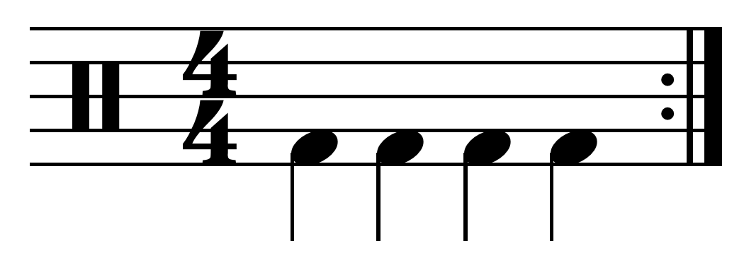

“Funk” Bass Pattern

